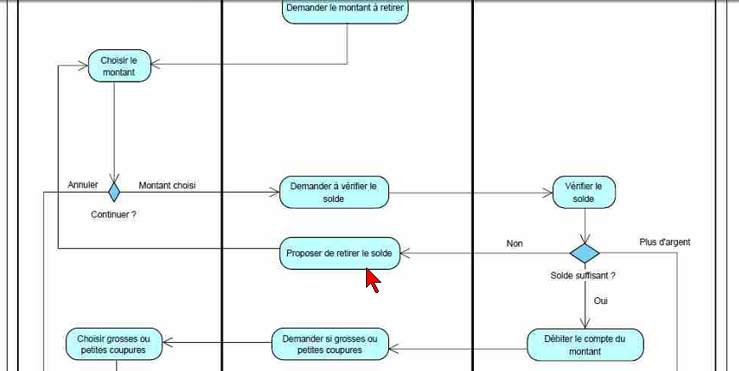

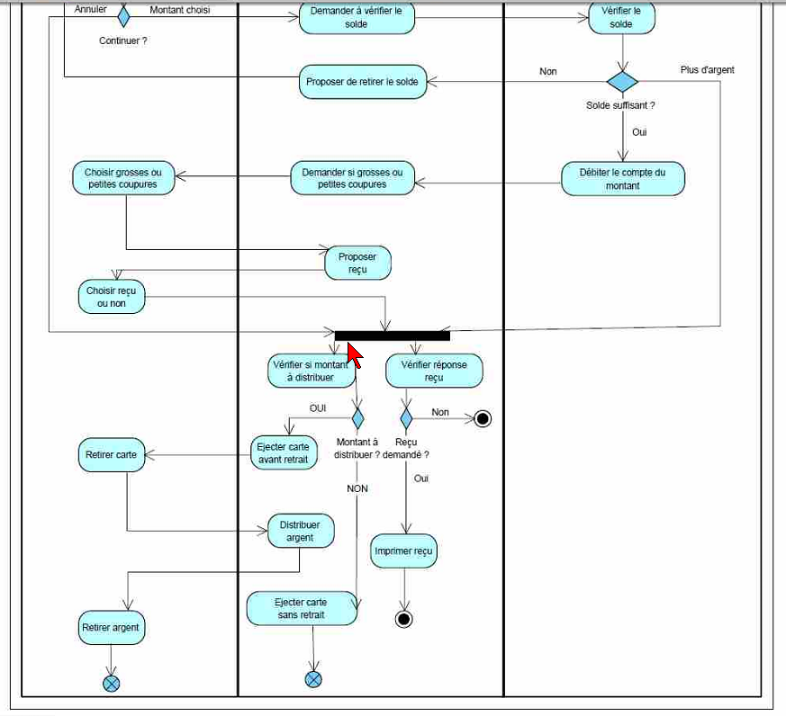

COM_STATUS, COM_STATUS, COM_CLI_ID, CLI_COMPAGNIE, EMP_PRENOM, 